**Referral System**

**User Guide**

Version 1.0



Technology developed by:

**REVISION HISTORY**

|  |  |  |  |
| --- | --- | --- | --- |
| **Version** | **Date** | **Description** | **Author** |
| V 1.0 | 25 – Feb – 2013 | Created | Mr. An Yon |
| V 1.0 | 10 – Apr – 2013 | Reviewer | Mr. Lim Chanmann |

**TABLE OF CONTENTS**

I- overview 1

Ii- objective 1

Iii- preface 2

Iv- referral system functionality 2

A- getting start 3

B- user management in referral system 6

1. Creating new user in referral system 6

2. Editing user in the system 8

3. Deleting user in the system 8

4. View, Add user from malaria day zero alert system 9

C- creating dynamic variable in the system 9

1. Editing dynamic variable 12

2. Deleting constrain in dynamic variable 12

3. Deleting dynamic variable 12

D- setting up message format in system 12

1. Setting up message format for private provider 12

2. Setting up message format for health center 14

3. Using criteria of static variable 15

E- setting up the template sms for user 16

F- the report in referral system 18

1. Viewing report in referral system 18

2. Searching report in referral system 20

3. Rectifying report in referral system 21

4. Editing report in referral system 22

5. Ignoring report in referral system 23

6. Unignoring report in referral system 23

7. Deleting report in referral system 23

8. Exporting report in referral system 25

G- sms testing in referral system 26

H- switching to malaria day zero alert system 28

I- log out referral system 28

# I- Overview

Reports indicate that more than 70% of malaria patients in Cambodia seek treatment via the private sector. The Public-Private Mix (PPM) project, initiated by the Cambodia National Malaria Program (CNM) and partners, uses public sector staff to help select and train registered private providers in accordance with National Treatment Guidelines (NTG’s). Among other things, private providers receive training on appropriate diagnosis, treatment and referral procedures. In accordance with NTG’s, private providers in malaria risk zones 2 and3 are permitted to diagnose and treat malaria cases although, children under five, pregnant women, and cases of serious/recurrent malaria should be referred to the public sector while private providers in malaria risk zone 1 should refer all malaria patients to the public sector.

Mechanisms are in place to gather case data from selected private providers; however, it continues to be problematic to track referrals from the private to the public sector. This population is often lost to follow up once they leave the private provider’s facility. The SMS based system being proposed is designed to help more effectively track patients and determine what happens to them after they are referred: do patients continue seeking treatment, where do they go, why don’t they go to the public sector, etc? Without the implementation of a tracking mechanism for these cases, it is impossible to know if these important patients are receiving the treatment they need.

# II- Objective

To develop an SMS system to more effectively track patients that are referred from the private to the public sector.

Specific Objectives

1. Follow up patients referred from registered private provider (PP) and monitor whether an SMS system was used to alert the corresponding health facility
2. To Follow up patients that never reached the health facility and assess what determining factors contributed to not accessing the public sector
3. To assess the user friendliness and acceptability of the SMS referral system to the private providers, the patient, and the public health facilities

# III- Preface

The completed documentation for this Referral System is provided below. Please contact InSTEDDiLabSoutheast Asia (email: [phnompenh@instedd.org](mailto:phnompenh@instedd.org)) for a copy of any of the following:

1. User Manual
2. Help Card for Private Provier
3. Help Card for Health Center staff
4. Technical documentation

# IV- Referral System Functionalities

1. Integrate with Malaria day zero alert system
2. Register private provider and health center staff to send and receive SMS
3. Register dynamic field(s) to receive SMS report from private provider and health center staff
4. Add validation for dynamic field
5. Design its own accepted SMS format
6. Customize system reply SMS template
7. Report dashboard
   * View (valid, error, duplicated, ignore) reports
   * Search reports by date
   * Rectify invalid report
   * Ignore testing reports
   * Delete reports
   * Simulate incoming SMS

**V- Referral System**

## Getting Start

In collaboration with [The National Center for Parasitology, Entomology and Malaria Control (CNM),](http://www.cnm.gov.kh/)[Clinton Health Access Initiative (CHAI)](http://www.clintonhealthaccess.org), and funded by the [Malaria Consortium Cambodia(MC)](http://www.malariaconsortium.org), the Referral System began development in November 2012. The Referral System is an SMS and web-based application that will enable private providers to message information about each referred patient into an online database. The message from private providers will include the referral slip number and patient’s phone number. When the patient arrives at the public clinic their referral slip information and number will be sent to the system by the health center so that the information can be matched up with the original referral submitted by the private provider.  With this information, the system at CNM is able to monitor patients so that they can see who was referred and which patients have been accounted for at public facilities and which have not.

Go to <http://md0.cnm.gov.kh/referral> to get started.

A user account is required to access the system. You can contact the system’s administrator for assistance obtaining a login account.

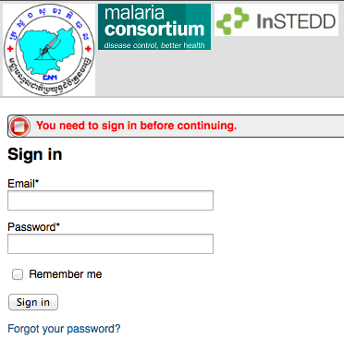

Once logged in as an administrator, you should see the following page:

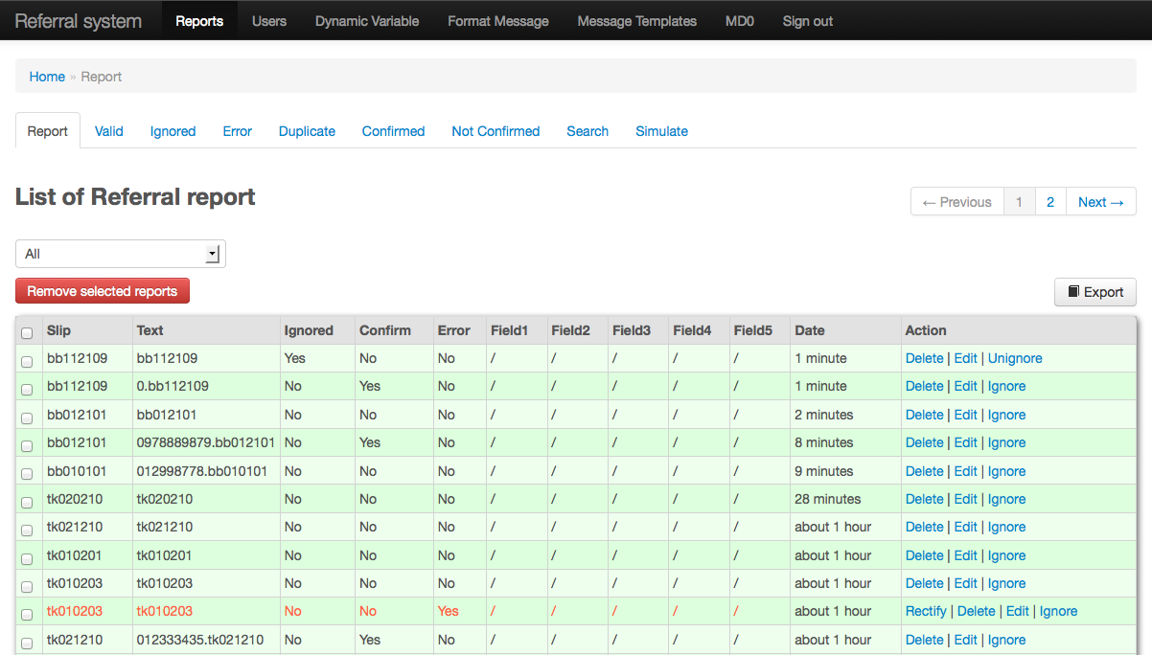

**1**

**2**

Below is the explanation of the screen above:

**1:** The header menu. There are seven difference menus:

* *Referral System:* Use to switch to Referral System by pressing this menu.
* *Reports:* Use this menu to show all kind of reports in Referral System. The report in referral system can be valid report, ignored report, error report, duplicate report, the report has been confirmed, report not yet confirm, searching report, and also as the administrator can do the SMS simulation as well.
* *Users:* This menu is used for manage the users in Referral System. The users in Referral System can be private provider, health center and facilitator.
* *Dynamic Variable:* It’s the flexible section of the system where administrator can add or delete the variable.
* *Format Message:* It’s the important part of the system where administrator can set the message format for private provider and health center to send the report via SMS to the system.
* *Message Template:* Using this menu to customize the acknowledgement message when the users send the report via SMS. There are successful acknowledgement and error.
* *MD0:* Clicking this menu to switch to Malaria Day Zero Alert System.
* *Sign out:* Clicking this menu to log out the system.

**2:** This section is used for display the object of the header menu. In default this section display the report.

## User Management in Referral System

Adding, deleting, or changing user setting in Referral System is related to the place of that user. But in Referral System the place structure is link with the place structure found in Malaria Day Zero Alert System and so we don’t need to add any places before add new user in Referral System.

In Referral System, there are 3 different users type:

* *Private Provider*: this role of user is for private clinic staff that sends the message when he/she refers the malaria patient to public health clinic.
* *Health Center*: this role of user is for health center staff that sends the referred patient confirmed visit message when that patient arrive health center for treatment.
* *Facilitator*: this role of user is for operational district representative. This user will receive the message when the private clinic send message to inform that he/she referred patient to health center and also when health center staff send the message to confirm that the patient arrived health center for treatment.

### Creating New User in Referral System

1. After login the system, click on**“Users”**menu



1. Click on button**“Register User”**

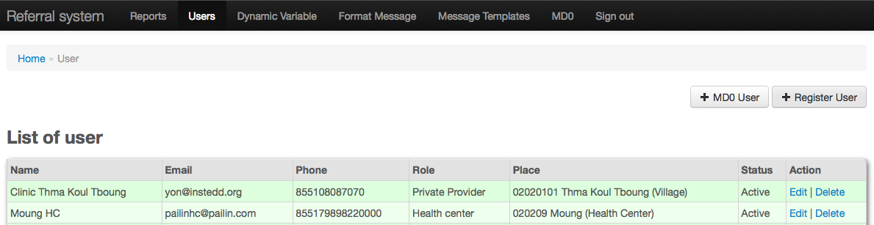

1. Fill in the new user information as the below information:

* **User name:** fill in the name of the user. This field is required.
* **Email:** fill in the email of the user. This field is not required.
* **Phone number:** fill in the phone number of the user. This phone number will be used for sending and/or receiving SMS. This field is required.
* **Password:** fill in the login password. This field is not required.
* **Password confirmation:**fill in the password again.
* **Role:** click the drop down box and choose the role for user. See the above description for the role of each user type.
* **Province:** click the drop down box select province.
* **OD:** click the drop down box select operational district.
* **Health Center:** click the drop down box select health center.
* **Village:** click the drop down box select village.
* **Status:** In default “Active” was chosen or choose “Deactive” if you’re not allow this user send or receive SMS after create.
* **Application:** In default “Referral System” was checked that mean that this user can use the Referral System only

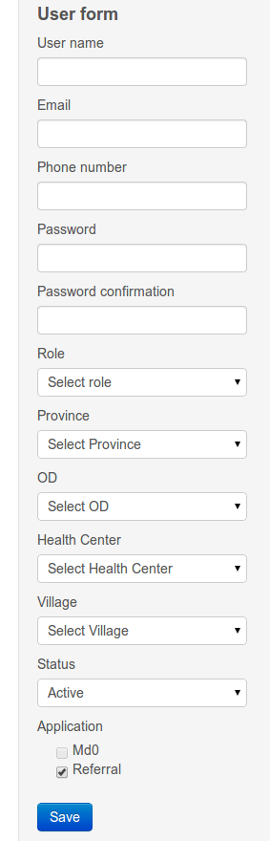

1. Click the **“Save”** button to create this user.

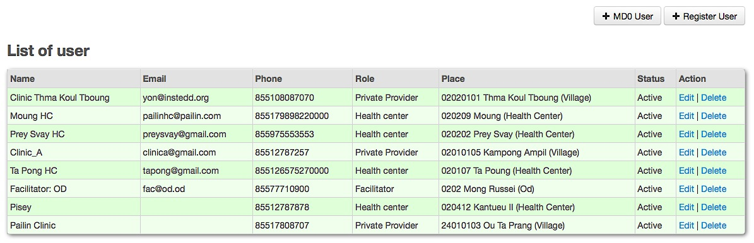

### Editing User in the System

After you have created user for the system, you can later edit them in the following manner:

1. Click on the **“Users”** menu
2. In the user list, click the **“Edit”** action for the user that you want to edit

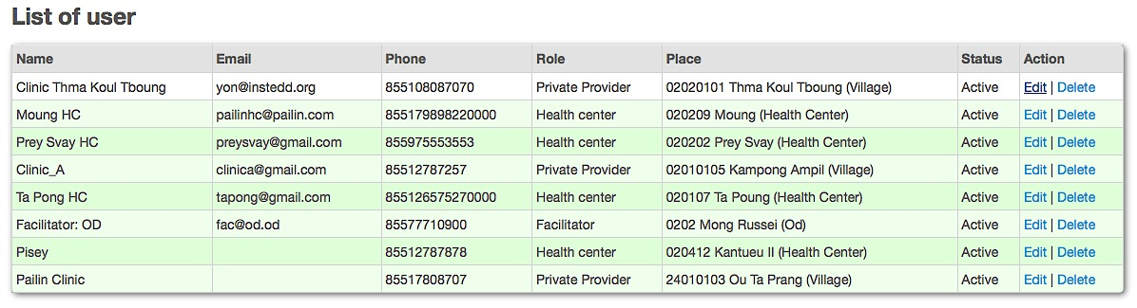

*This screenshot shows the editing user “Clinic ThmaKoulTboung”*

1. Edit the user as appropriate
2. Click the **“Save”** button

### Deleting User in the System

1. Click on the **“Users”** menu
2. Click the **“Delete”** action for the user that you want to delete
3. Click the **“OK”** button to confirm deletion.

*Note:* you cannot delete the user who used to report to the system.

### Add user from Malaria Day Zero Alert System

1. Click on the **“Users”** menu
2. Click on **“MD0 User”** button

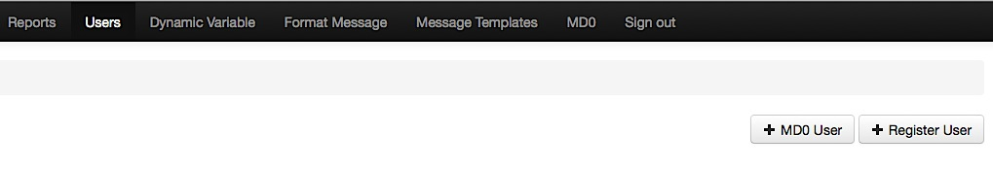

The list of users in Malaria Day Zero Alert System will be shown as the below screenshot.

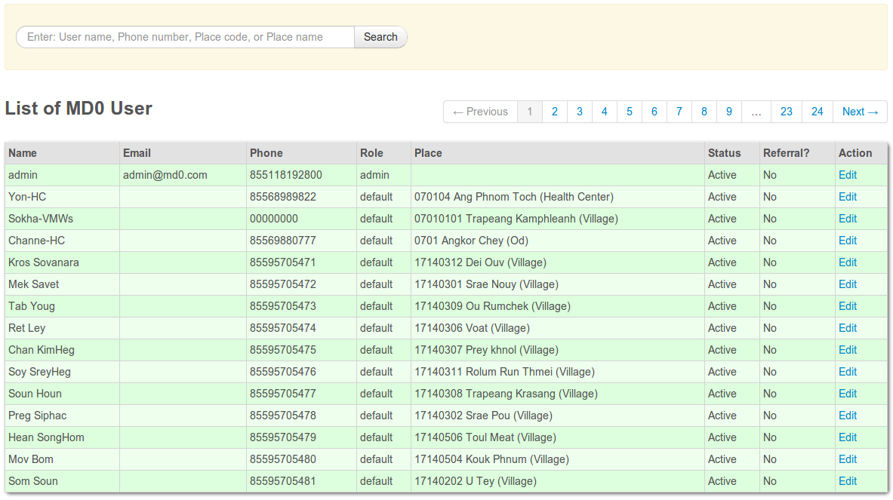

1. Click on **“Edit”**
2. Check “**Referral**” checkbox to add the user to Referral system

## Creating Dynamic Variable in the System

Dynamic variable is the special feature of Referral System that allows administrator to create more variables beside the existing static variables. In Referral System we reserve 5 dynamic variables. The steps below are showing how to create dynamic variable.

1. Click on **“Dynamic Variable”** menu. The system will display as the below screenshot:
2. Click **“Create”** link of the first field to start create the first dynamic variable.

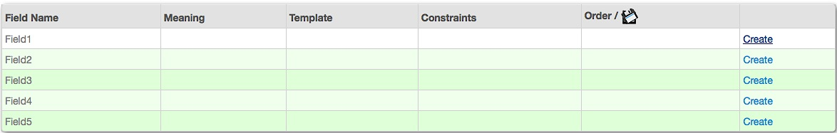

1. Fill in the information of new dynamic as below:

* ***Meaning:*** fill in the name of variable.
* 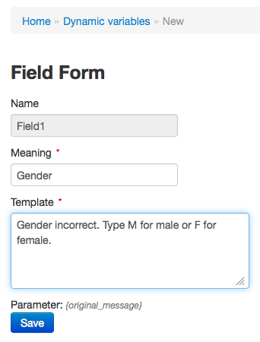***Template:*** fill in the text to acknowledge to user when sending wrong condition.

*This screenshot show the creating dynamic variable “Gender”*

1. Click **“Save”** button.
2. Click on **“Constrains”** link of the variable that just created to set its condition

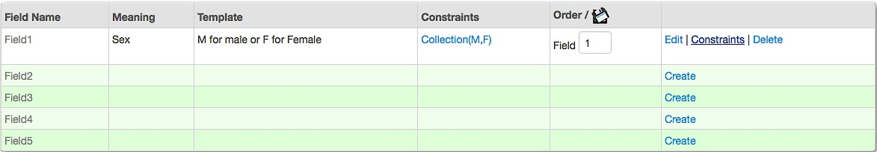

1. Choose the constraint type in from the dropdown box. There are eight difference condition:

* ***Between:*** for setting range of value as number that allow user to input. Example: if the value is set between 0 and 10, it means that user can input value from 0 to 10 only for this variable.
* ***Collection:*** for setting the list of values that allow user to input. The values must be separated by comma. Example: if the collection is set as **M,F** it means that user can input M or F only for this variable.

Note: Space between , is not supported

* ***DifferenceFrom:*** for setting the value that not allow user to input. Example: if the DifferenceFrom is set as **10** it means that the user cannot input 10 for this variable.
* ***EqualTo:*** for setting the value that allow user to input only the same as it is set. Example: if the EqualTo is set as **10** it means that the user can input 10 only for this variable.
* ***Length:*** for setting the exactly length of input value. Example: if the Length is set as **10** it means that the user has to input 10 characters for this variable.
* ***Max:*** for setting the maximum number for the variable. Example: if the Max value is set as **100** it meant that the user couldn’t input number more than 100.
* ***Min:*** for setting the minimum number for the variable. Example: if the Min value is set as **0** (zero) it meant that the user couldn’t input number less than 0.
* ***StartWith:*** for setting the starting character for the variable. Example: if the StartWith value is set as **M** it mean that the user has to input the value start with letter M for this variable.

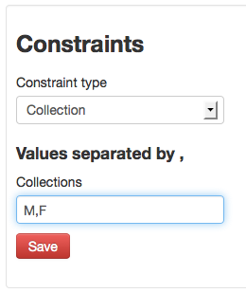

*This screenshot show the constraint setting that is can type M or F only.*

1. Click **“Save”** button.

**Note that we can create more than one constraint for one variable.

Click on **“Dynamic Variable”** to go back to the list of dynamic variable. Follow the steps above if you want to create another dynamic variable.

### Editing Dynamic Variable

1. Click on **“Dynamic Variable”** menu
2. Click on **“Edit”** link of the variable that you want to edit
3. Edit the variable as needed.
4. Click **“Save”** button to save it.

### Deleting Constrain in Dynamic Variable

* + - 1. Click on constraint name of the variable that you want to delete.

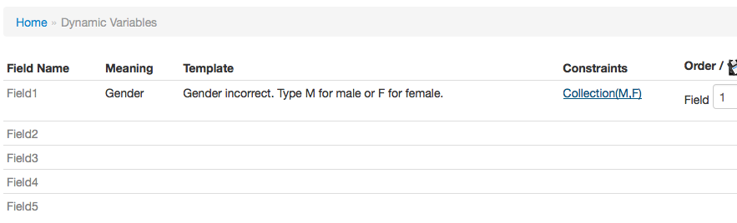

* + - 1. Click on **“Delete”** link of the constraint to delete it
      2. Click**“Yes”** button to confirm delete.

### Deleting Dynamic Variable

* + - 1. Click on **“Delete”** of the variable that you want to delete
      2. Click **“Yes”** button to confirm

** Note that when the dynamic variable was deleted, all the constraints set for this variable also deleted.

## Setting up Message Format in System

Referral System allows the administrator to set the message format. Message format is the template that private provider and health center will use for sending referred patient information or health center confirm the referred malaria patient via SMS.

### Setting up Message Format for Private Provider

1. Select the **“Format Message”** menu.
2. Click the variable in section Private Provider to add to the format message box.

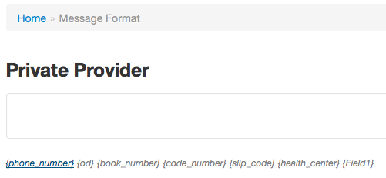

*This screenshot show that administrator want to add “phone_number” variable as format message for private provider.*

1. Click on other variable to add more

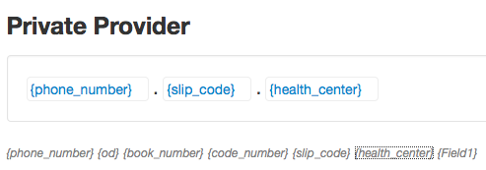

*This screenshot show the format message for private provider to send the referred malaria patient via SMS is* ***phone_number.slip_code.health_center****which is separate by dot (.).*

Administrator also can remove variable from message format by clicking on the variable in the message format box.

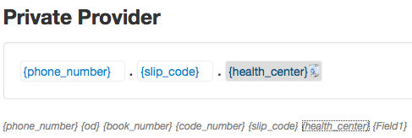

*This screenshot show that administrator want to remove variable* ***health_center***

1. Click the **“Save”** button to save the message template for private provider.
2. To make sure that the format message is working well, administrator can test this template in Test Parser.

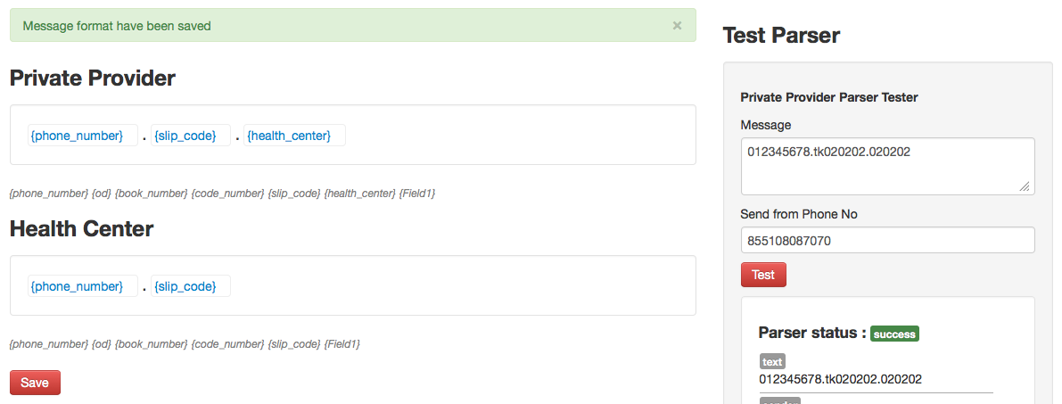

### Setting up Message Format for Health Center

1. Select the **“Format Message”** menu.
2. Click the variable in section Health Center to add to the format message box.

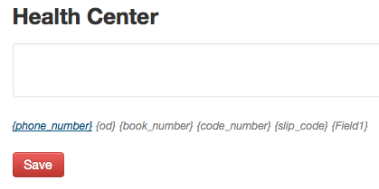

*This screenshot show that administrator want to add “phone_number” variable as format message for health center.*

1. Click on other variable to add more

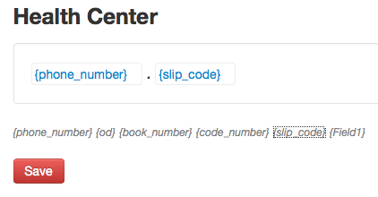

*This screenshot show the format message for health center to send the confirmed visit for referred malaria patient via SMS is* ***phone_number.slip_code*** *which is separate by dot (.).*

Administrator also can delete any variable already added by click on the variable in the message format box.

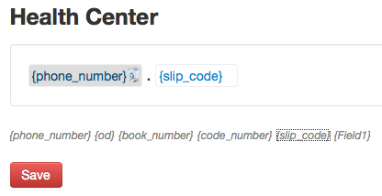

*This screenshot show that administrator want to remove variable* ***phone_number***

1. Click the **“Save”** button to save the message template for health center.
2. To make sure that the format message is working well, administrator can test this template in Test Parser.

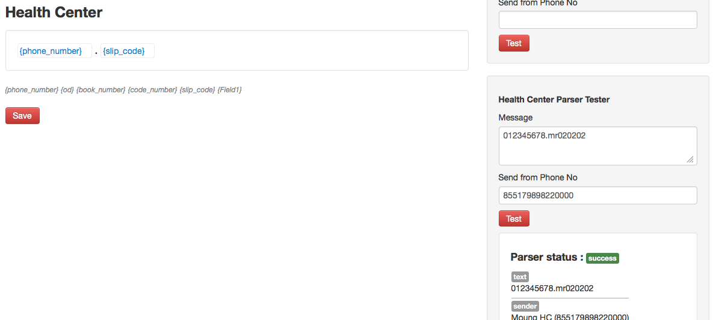

### Using Criteria of Static Variable

In Referral System, there are 6 existing static variables:

* ***{phone_number}:*** is the phone number of referred malaria patient. The format phone number must be 9 or 10 digit but in case of the referred patient have no phone number, must type 0 (zero).
* ***{od}****:* is the abbreviation of operational district. Please see the abbreviation setting for places of Malaria Day Zero Alert System.
* ***{book_number}***: is the book number that requires 3 digits.
* ***{code_number}***: is the code number that it requires 3 digits.
* ***{slip_code}***: is the referred code that is normally the combination between {od}+{book_number}+{code_number}.
* ***{health_center}****:* is the code of health center that is provided by operational district. The health center code must be 6 digits.

## Setting up the Template SMS for User

In Referral System is enabled for administrator to customize the message that will alert to private provider, health center and facilitator they send the referred malaria patient to the system. You can set both error and success message.

Select the **“Message Templates”** menu.

Setting up the message template as the following description:

* ***Private Provider Acknowledgement****:* is used for setting up the acknowledgment message when private provider successfully sent the referred malaria patient to the system.
* ***Private Provider to Health Center****:* is used for setting up the message that will forward to health center when private provider successfully sent the referred malaria patient to the system.
* ***Private Provider to Facilitator****:* is used for setting up the message that will forward to facilitator when private provider successfully sent the referred malaria patient to the system.
* ***Health Center to Private Provider****:* is used for setting up the message that will forward to private provider when health center successfully sent the confirmation of referred malaria patient.
* ***Health Center Acknowledgement****:* is used for setting up the acknowledgement message back to the sender when private provider successfully sent the confirmation of referred malaria patient.
* ***Invalid Phone Number:*** is used for setting up the acknowledgement message back to the sender when send SMS to the system with wrong format phone number.
* ***Invalid Book Number:*** is used for setting up the acknowledgement message back to the sender when send SMS to the system with wrong format book number.
* ***Invalid Code Number:*** is used for setting up the acknowledgement message back to the sender when send SMS to the system with wrong format code number.
* ***Invalid OD Abbreviation:*** is used for setting up the acknowledgement message back to the sender when send SMS to the system with wrong operational district abbreviation.
* ***Invalid user for OD:*** is used for setting up the acknowledgement message back to the sender when send SMS to the system with OD abbreviation, which is sender, is not in that OD.
* ***Invalid Health Center Format:*** is used for setting up the acknowledgement message back to the sender when send SMS to the system with wrong format of health center code.
* ***Invalid Health Center Code:*** is used for setting up the acknowledgement message back to the sender when send SMS to the system with health center code is not exist.
* ***Parser Items Mismatched:*** is use for setting up the acknowledgement message back to the sender when send SMS to the system with wrong format message.
* ***Validator Not Found:*** is used for setting up the acknowledgement message back to the sender when send SMS to the system by using the validator used in format message is not found.
* ***No Slip Code found in Clinic:*** is used for setting up the acknowledgement message back to the health center who sent SMS to the system by using the slip code which is not have on private provider.

Click on **“Save”** button to save the setting.

## The Report in Referral System

The list of report in Referral System is message that received from the private clinic when sent the referred malaria patient and when health center sent the confirmation of refereed malaria patient.

### Viewing Report in Referral System

1. Login to the Referral System
2. Select the **“Reports”** menu. This menu is normally automatic select when login to the system.
3. Click on:

* **“Report”** tab if you want to view all type of report in Referral System. This tab is normally selected when the Reports menu was selected.
* ***“Valid”*** tab if you want to view the list of correct repot.
* ***“Ignored”*** tab if you want top view the list of report that is discarded by system admin and the report come from simulation.
* ***“Error”*** tab if you want to view the list of incorrect report.
* ***“Duplicate”*** tab if you want to view the list of reports that user sent the same report in the same day.
* ***“Confirmed”*** tab if you want to view the list of reports that has been confirmed by health center.
* ***“Not confirmed”*** tab if you want to view the list of reports that not yet confirm by health center.

1. Click on dropdown list to choose the report from private clinic or health center. By default, Referral System shows both reports from health center and private clinic.

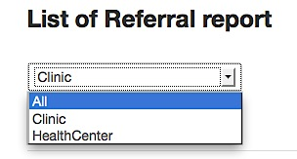

For view both report from private clinic and health center

For view report from private clinic only

For view the report from health center only

1. Click on pagination number to view next or previous report page.

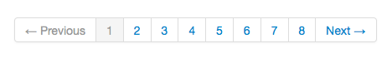

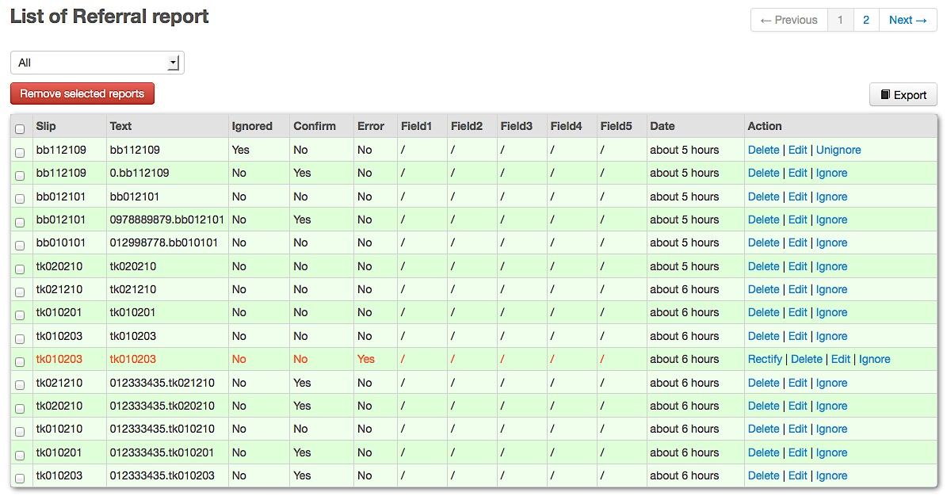

*This screenshot show all the report type and both private provider and health center report of Referral System. The reports with red color are error report.*

Below is the description of report header row.

* **SlipCode**: slip code of referred patient.
* **Sender**: phone number of private provider (clinic) sending the message.
* **Text**: message text.
* **Ignored**: ignored report status. “**Yes**” mean that the report has been ignored, otherwise show “**No**”.
* **Confirm**: will show the phone number and name of health center in bracket when there is a confirmation from health center of referred patient.
* **Error**: error indicator. “**Yes**” mean that the report is an error report with red color, otherwise show “**No**”.
* **Field1…5**: are the reserved columns for dynamic variables. These fields name and its meaning are flexible depend on the meaning of dynamic variables you created.
* **Date**: for showing how many days the report has been reported.
* **Action**: the action links that allow administrator to Rectify, Delete, Edit, Ignore, and Unignore the report.

### Searching Report in Referral System

1. Login to the Referral System
2. Select the **“Reports”** menu
3. Click on **“Search”**

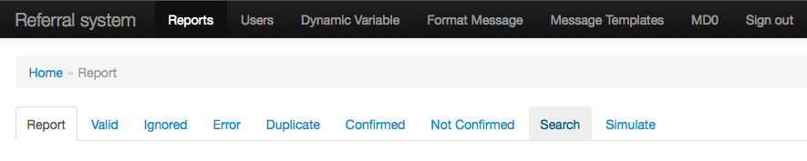

By default, Referral System shows all reports.

1. Choose the rank date that you want to view the report from **“From”** and **“To”** text box or/and type the keyword to search.
2. Click on **“Search”** button.

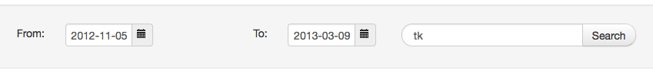

*This screenshot show that we want to search the report received from 5 November 2012 to 9 March 2013 with the keyword tk.*

Below is the screenshot of result from the search condition above.

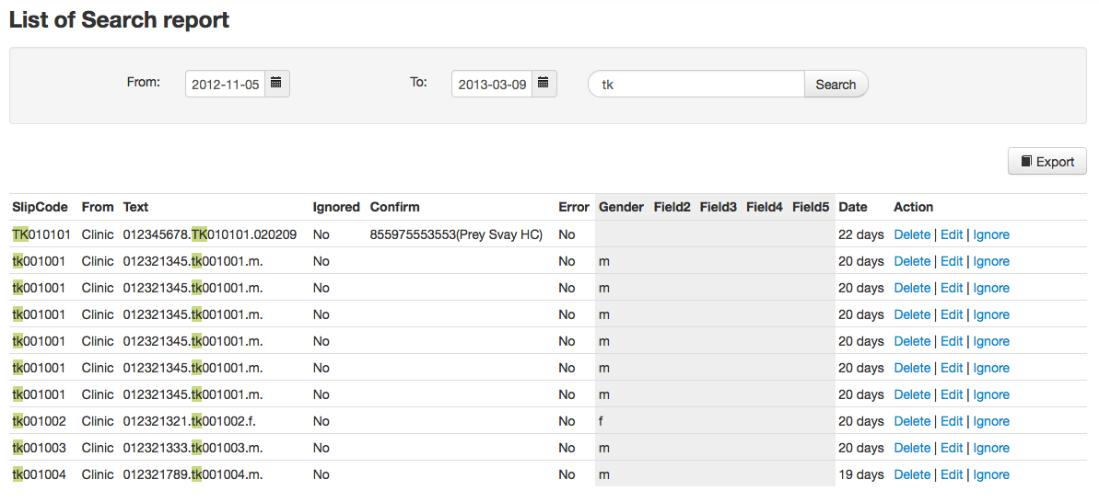

### Rectifying Report in Referral System

As a system administrator want to edit and correct the error report. The report will count as valid report after successfully rectified. Note that we can rectify error report only.

1. Login to the Referral System
2. Select the **“Reports”** menu. This menu is normally automatic select when login to the system.
3. Click on **“Error”** tab.
4. Click on **“Rectify”** link under action column of the error report that you want to rectify.

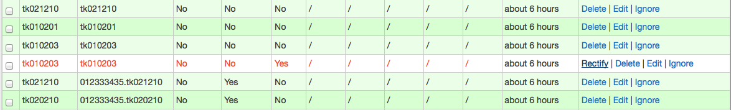

1. Edit the report as you want

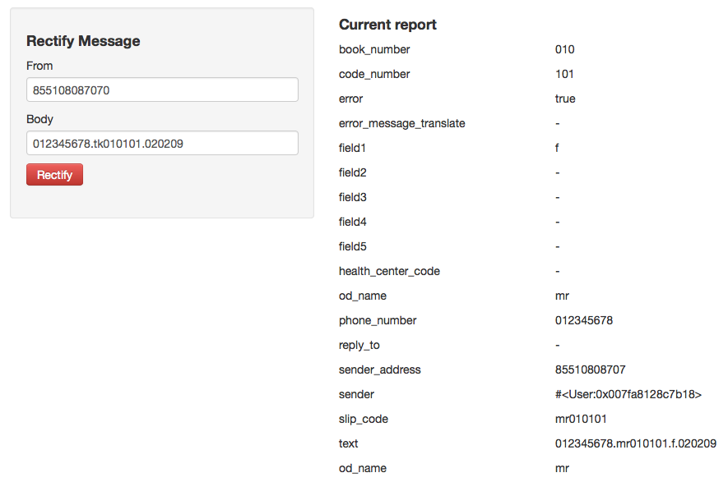

Original report

Rectified report

1. Click **“Rectify”** button.

### Editing Report in Referral System

1. Login to the Referral System
2. Select the **“Reports”** menu. This menu is normally automatic select when login to the system.
3. Click on **“Edit”** link under action column of the report that you want to edit.

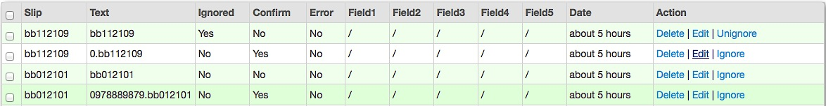

*This screenshot show that we want to edit the second row of Referral Report.*

1. Edit the report as you want

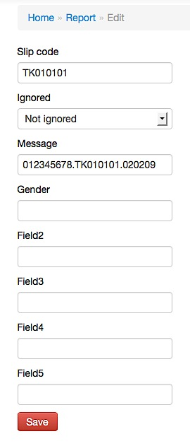

1. Click **“Save”** button.

### Ignoring Report in Referral System

1. Login to the Referral System
2. Select the **“Reports”** menu. This menu is normally automatic select when login to the system.
3. Click on **“Ignore”** link under action column of the report that you want to ignore.

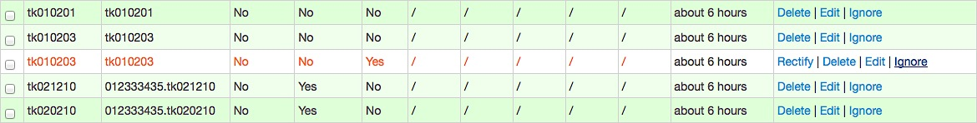

*This screenshot show that we want to ignore the red report. This report will be moved to ignore report. Click on* ***“Ignored”*** *tab to view this report.*

### Unignoring Report in Referral System

1. Login to the Referral System
2. Select the **“Reports”** menu. This menu is normally automatic select when login to the system.
3. Click **“Ignored”** tab
4. Click on **“Unignore”** link under action column of the report that you want to unignore

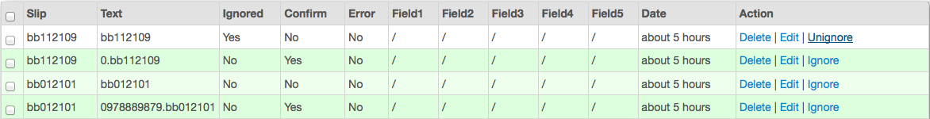

*This screenshot show that we want to unignore the first row of Referral Report. This report will be moved to valid report. Click on* ***“Valid”*** *tab to view this report.*

### Deleting Report in Referral System

1. Login to the Referral System
2. Select the **“Reports”** menu. This menu is normally automatic select when login to the system.
3. Click on **“Delete”** link under action column of the report type that you want to delete.

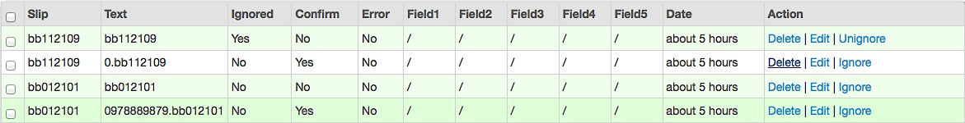

*This screenshot show that we want to delete the second row of Referral Report.*

1. Click **“OK”** button to confirm delete

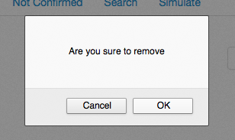

You can delete more than one report a time by check on the report that you want to delete🡪 click **“Remove selected reports”** button 🡪 click **“OK”**

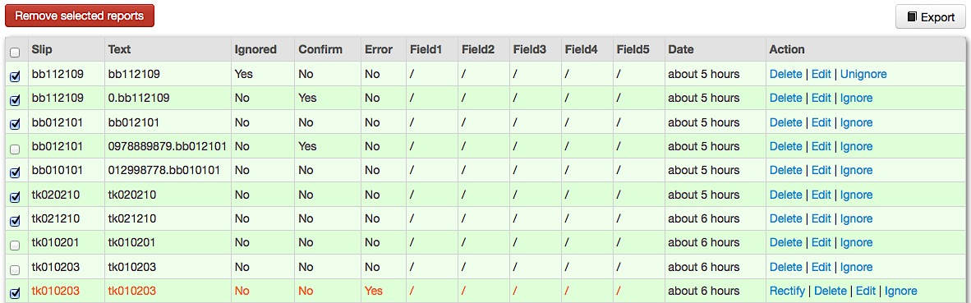

### Exporting Report in Referral System

1. Login to the Referral System
2. Select the **“Reports”** menu. This menu is normally automatic select when login to the system.
3. Choose the report type that you want to export
4. Click on **“Export”** button

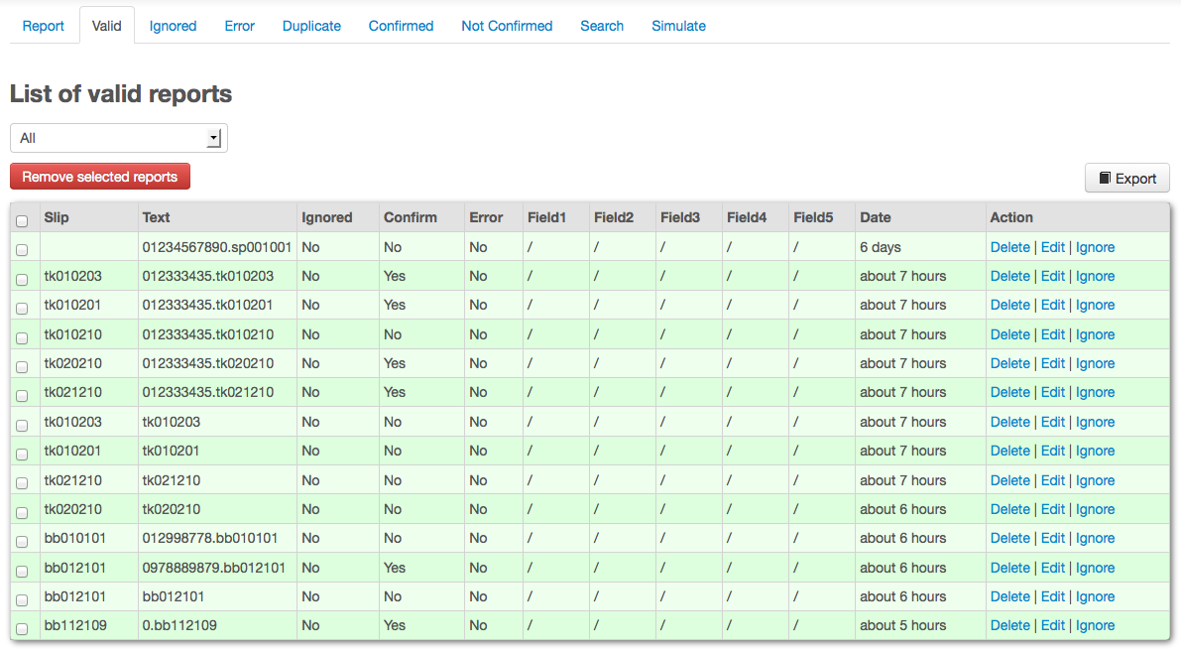

## SMS Testing in Referral System

This function helping system administrator act as user and testing by send message. The system will reply and let you know that the user with phone number and the format message you have set is correct or incorrect and what are the phone number will be sent and what kind of text to be sent.

1. Login to the Referral System
2. Select the **“Reports”** menu. This menu is normally automatic select when login to the system.
3. Click on **“Simulate”** tab.

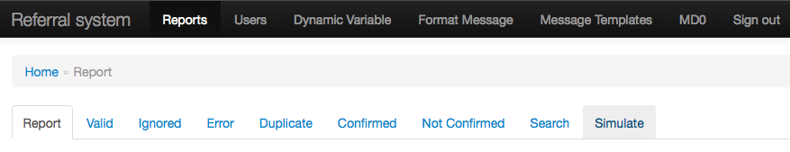

1. Fill in the require information bellow:

* **From:** fill in the phone number of user that you want to test.
* **Body:** fill in the message going to send. This message follows the format message you have set.
* **Guid:** fill in any text. It’s optional.

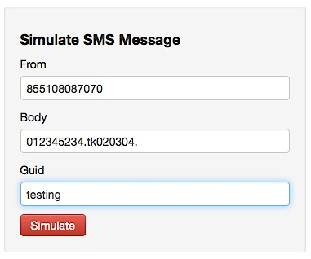

*This screenshot show that we want to simulate user with phone number 855108087070*

1. Click button **“Simulate”.**

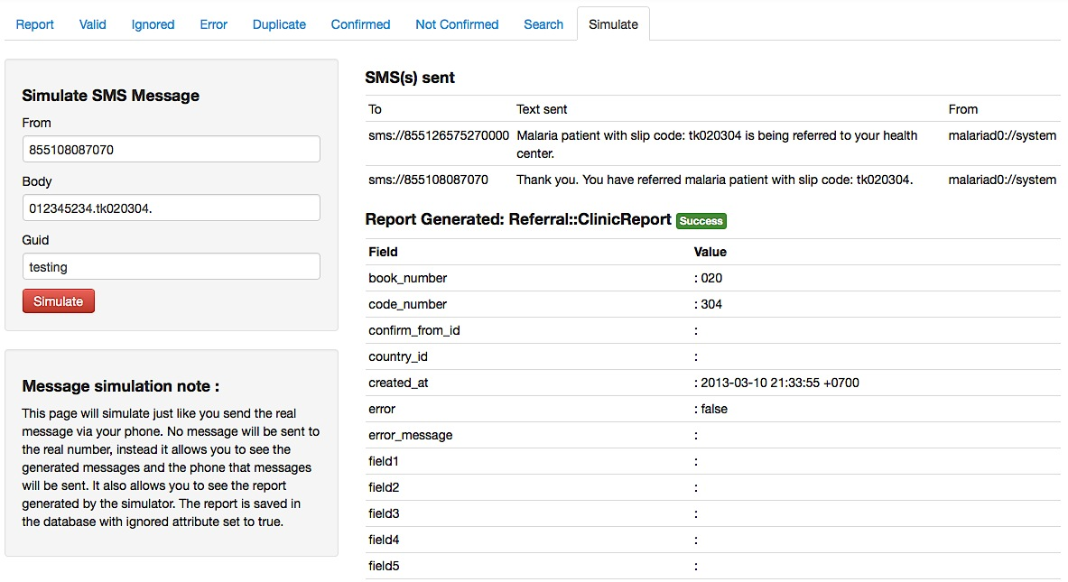

*This screenshot show the simulation is success with the user with phone number 855108087070. System also send acknowledgement message to 855126575270000 and 855108087070.*

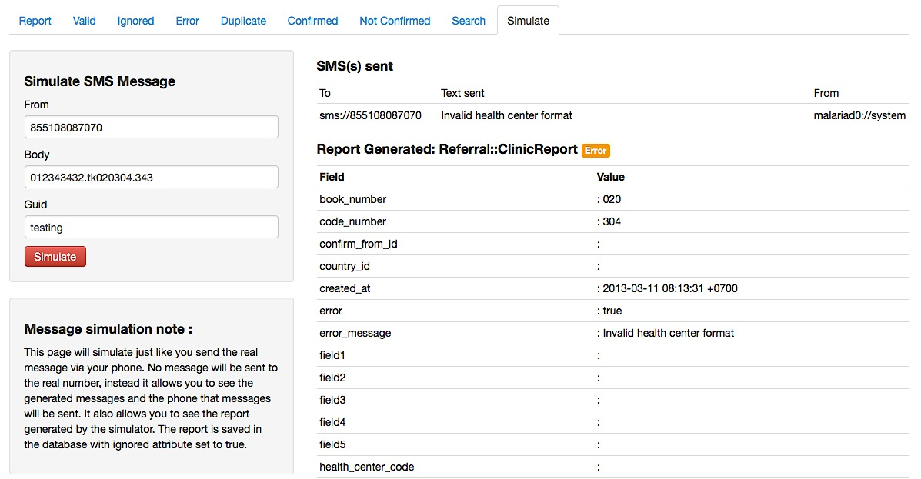

*This screenshot show the simulation is not success with the user with phone number 855108087070. System also send acknowledgement message to 855108087070 by telling invalid health center format.*

## Switching to Malaria Day Zero Alert System

In Referral System, you just click on **“MD0”** menu to switch to Malaria Day Zero Alert System.



## Log out Referral System

Click on **“Sign out”** to log out the Referral System.



The system will show the log in screen as bellow:

